Team 9 CSC 4350:

Software Engineering

Dr. Rao Casturi

Team Members:

1. Stuti Nishantkumar Patel
2. Mohit K. Ratnapu
3. Iori K. Sasahara
4. Nicholas P. Pappachristou
5. Yeabsira H. Tamene
6. Caleb B. Rumsey

Project Name: **Georgia State University Student Planner (GSU STPL)**

**Project Description**

**Introduction**

In 2020, Georgia State University had over 28,772 students enrolled according to US News. The National Center for Education Statistics states that Forty percent of students who enroll in a four-year college don’t graduate within six years. We believe in the case of many students, dropping out or delayed graduation could have been easily prevented if students had a clearer idea of what they needed to accomplish to graduate.

Our idea is a simple but effective one for GSU students. While one might see a planner to have a small significance in one’s college career, we believe that having one tailored specifically to GSU would greatly decrease the percentage of students not graduating on time or at all. Our idea is to have a schedule website that can be accessible to any GSU student and can be tailored to their specific needs while at GSU. We plan to implement features such as a GPA calculator, a class navigator, a list of what classes you’ve taken and what you need as well as a four-year plan of study for each degree and a plethora of other features.

Of course, these features can easily be done with other apps, websites or can even be done by hand with a notebook and pen. However, by building this site we aim to simplify the process of using multiple tools to see if you’re on track for graduation. It can remove tedious steps of a student struggling to figure out all the information on their own which can potentially discourage a student or make them lose motivation.

**Technologies**

At this time, some of the technologies are to be determined as of now while we’re still in our planning phase. What we do know is that we will certainly be needing to use HTML, CSS, and Java Script for our site. Our plan as of now is to use WordPress as our host for our site. We are also considering how best to implement a database for the site. We are also in the process of figuring out how to best pull data from other sites such as PAWS.

**Visual Concepts:**

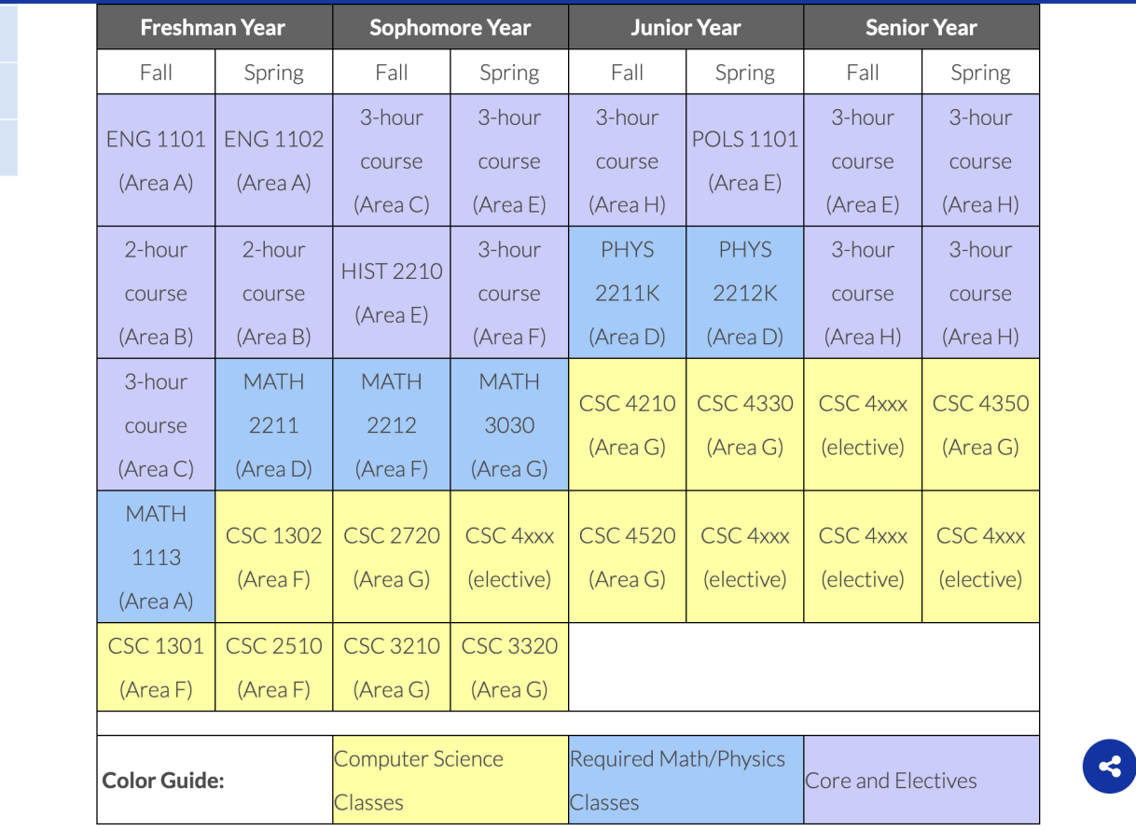

* + - 1. Design/Layout (So we can decide the base size of the project: Important to decide what to put in the limited space.)
      2. Create the border/template for the project.
      3. Implement

**Team-Bio Data**

**Stuti Patel:** I am a Senior Computer Science student at Georgia State. I have taken 4000 level courses such as Design & Analysis of Algorithms, Web Programming and Computer Networks. This semester, I am taking Fundamentals of Cybersecurity, Mobile Computing and Wireless Network Security and Programming Language Concepts. I am familiar with Java, C++, Python, HTML, JavaScript and some CSS. I am trying to improve my programming skills with some personal projects. I recently made a chrome browser extension to increase productivity and promote privacy aware browsing habits.

**Member 2:** is a senior CS student at GSU with nearly 3 years of school related programming experience. Member 2 has moderate/intermediate knowledge of Java, HTML, and CSS is also familiar with MySQL, JavaScript and PHP. She has done many front-end assignments/projects through the web development class offered at GSU. Member 2 is interested in working with and learning new technologies, such as python. She has good time management skills and is fairly adaptable and flexible to any changes.

**Iori Sasahara:** I am also in my senior year as a Georgia State University majoring Computer Science. I’m still in progress with my 4000 level courses such as this class and Fundamentals of Game Design, but I’ve taken Design & Analysis: Algorithms and some Art & Design classes back when I used to be in UGA. I am most familiar with Java and C++. I can’t confidently say that I am great with both languages but it's at the level where I can code some Tetris and simple puzzle games. Right now, I am studying for 3D modeling, Excel, and PowerPoint Certificate on my own and planning to find an internship that could level up any of the skills. (Of course, coding’s too)

**Nicholas Pappachristou:** I am in my senior year here at Georgia State University studying Computer Science. I originally started at Georgia Gwinnett College where I majored in Information Technology. Some highlights of CS courses I have taken at GSU are Privacy, Web Programming, Computer Animation and Fundamentals of Game Design. For work, I am employed by Tech Corps as an instructor. I am usually assigned to teach App/Game Design and general intro level programming at their many camps.

**Yeabsira Tamene:** I am a Senior Computer Science student at Georgia State. I have taken 4000 level courses such as Web Programming, Design & Analysis: Algorithms, and Big Data Programming. I am currently taking Networking, Cybersecurity, and Operating Systems courses. I am most familiar with coding with Java and have intermediate skills with python, HTML, and CSS. Most recently I worked on building a mobile app native for iOS that utilized public API’s and a big data project that processed massive data sets with a focus on algorithms to evaluate and create a competitive study.

**Caleb Rumsey:** I’m a Computer Science student here at Georgia State, I’ve taken all the regular CS classes we’ve all taken but also have taken Web Programming, Mobile App development, Big Data Programing, and Operating Systems. In my professional life I work as a Security Operations Engineer primarily working with Linux based systems hardening and monitoring them from outside threats. I have large amounts of Cybersecurity experience however for this course/project the skills I’ve learned managing databases and implementing said databases into apps, websites, etc. I wouldn’t say I'm the absolute best at programming regular languages (Java, Python, etc.) because I have more experience with minute languages like YAML and SQL but with research and teamwork I can pick new talents up fast.

**Why did we pick this project?**

We believe what makes GSU unique is that it accepts students from all different types of backgrounds. You have students who live on campus and commuters. There are also students who are from Georgia and those from out of state or are international students. There are also certainly students who are the first in their families to attend college. It can sometimes be a tough transition to GSU, whether you’re just coming from high school, transferring from another institution, or are returning from a long hiatus. We believe our project will help ease and prepare students not only for their transition, but for their entire time at Georgia State University.